ST.ANNE’S
COLLEGE OF ENGINEERING AND TECHNOLOGY
(An ISO 9001:2015 Certified Institution)
Anguchettypalayam, Panruti – 607106.
QUESTION BANK
PERIOD: JULY - NOV 2018 BATCH: 2015 – 2019
BRANCH: ECE YEAR/SEM: II/III
SUB CODE/NAME: EC 8391– CONTROL SYSTEMS ENGINEERING
UNIT I
SYSTEMS COMPONENTS AND THEIR REPRESENTATION
PART - A
- What is meant by a system?(D)
- Write Mason’s Gain formula.(D)(NOV/DEC 2011, NOV/DEC 2010, MAY/JUNE 2013, MAY/JUNE 2014, NOV/DEC 2014, MAY/JUNE 2015, MAY/JUNE 2016)
- What are the three basic elements in electrical and mechanical system?(D)(NOV/DEC 2010)
- How will you get closed loop frequency response from open loop response?(ID)(NOV/DEC 2010)
- List out the advantages of closed loop and open loop control system.(D)(APR/MAY 2010, MAY/JUNE 2012, NOV/DEC 2012, MAY/JUNE 2014, APR/MAY 2015, APR/MAY 2017)
- State ‘‘transfer function’’ of a system.(D)(APR/MAY 2010, NOV/DEC.2010, NOV/DEC 2013, NOV/DEC 2014, APR/MAY 2017)
- What is analogous systems?(D)(NOV/DEC 2013)
- What are the basic elements of a control systems?(D)(NOV/DEC 2014, MAY/JUNE 2016, NOV/DEC 2016)
- Write the force balance equation for ideal dashpot and ideal spring.(D)(APR/MAY 2015)
- What is Control Systems?(D)(NOV/DEC 2016)
- Differentiate between open loop and closed loop control systems.(D)(NOV/DEC 2010, NOV/DEC 2014, MAY/JUNE 2016, APR/MAY 2017)
- Prove the rule for eliminating negative and positive feedback loop.(D)
- Name any two dynamic models used to represent control systems.(ID)(MAY/JUNE 2013)
- What are the characteristics of negative feedback? (D)(MAY/JUNE 2014, APR/MAY 2017)
- What is translational system? (D)
- Give the types of friction.(ID)
- What is block diagram? (D)( APR/MAY 2017)
- List the advantages of block diagram. (D)
- What do you mean by a node in signal flow graph? (ID)
- List the advantages and disadvantages of feedback system. (D)
- What is synchros? (D)
- Define A.C servomotor? (D)
- Define D.C servomotor? (D)
- What is an actuating signal? (ID)
- What is a command input? (ID)
- What is signal flow graph?(D)
- What is the need for signal flow graph?(D)
- Why negative feedback is preferred over positive feedback system? (ID)(NOV/DEC 2016)
- What are the advantages of the closed loop control system? (D)May/June 2012& Nov/Dec - 2012
- What are the properties of signal flow graphs? (D)May/June 2012
PART – B
[First Half]
Mechanical Translational System
- Write the differential equation governing the mechanical translational systems shown in the figure and find the transfer function (D)(MAY/JUNE 2016) (13 Marks)
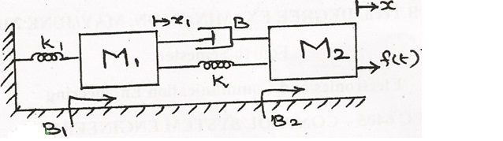
- Write the differential equation governing the mechanical translational systems shown in the figure and find the transfer function (D)(NOV/DEC 2013)(13 Marks)
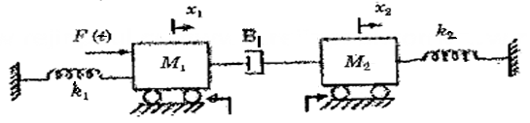
No Friction
- Write the differential equation governing the mechanical translational systems shown in the figure and find the transfer function(D)(APR/MAY 2017)(13 Marks)
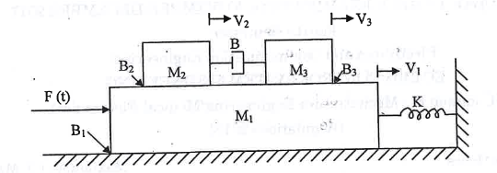
Mechanical Rotational System
- Write the differential equation governing the mechanical rotational systems shown in the figure and find the transfer function. Consider the angular displacement in J₁ as θ₁(D)(MAY/JUNE 2013)(13 Marks)

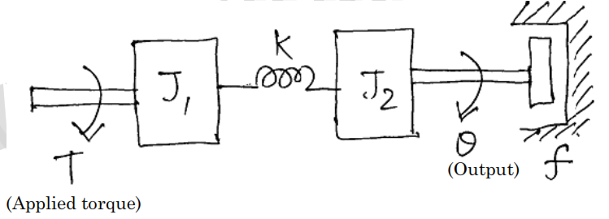
Electrical Analogous Circuits (MTS)
- Obtain the transfer function of the given mechanical system. Hence the draw electrical analogous circuits.(ID) (NOV/DEC 2014)(13 Marks)
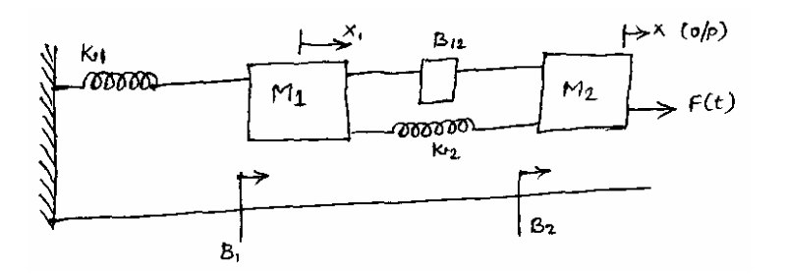
- Write the differential equation governing the mechanical translational systems shown in the figure. Draw the Electrical analogous circuits. (D) (MAY/JUNE 2015)(13 Marks)
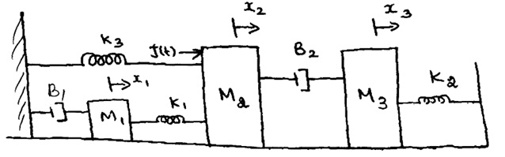
- Write the differential equation governing the mechanical translational systems shown in the figure. Draw the Electrical analogous circuits. (D) (MAY/JUNE 2013)(13 Marks)
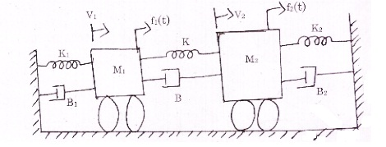
- Write the differential equation governing the mechanical translational systems shown in the figure. Draw the Electrical analogous circuits. (D) (13 Marks) (MAY/JUNE 2013)

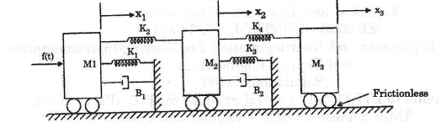
Electrical Analogous Circuits (MRS)
- Write the differential equation governing the mechanical rotational systems shown in the figure. Draw the Electrical analogous circuits with two angular displacement θ₁ and θ₂ (D) (13 Marks) (NOV/DEC 2016)
[Second Half]
Block Diagram Reduction Technique
- Reduce the given block diagram and find the overall transfer function. (D) (13 Marks) (NOV/DEC 2016)
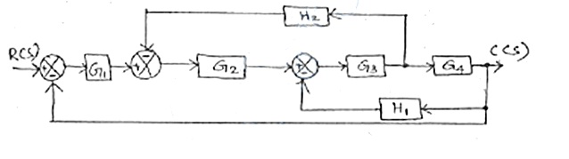
- Reduce the given block diagram and find the overall transfer function. (D) (13 Marks) (NOV/DEC 2014)
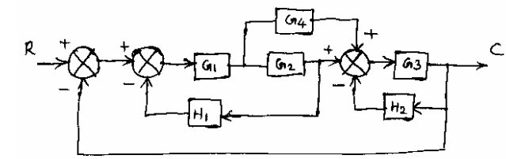
- For the system represented by the block diagram given below, evaluate the closed loop transfer function, when input R is (i) at Station 1 and (ii) at Station 2 (D) (13 Marks) (NOV/DEC 2013)
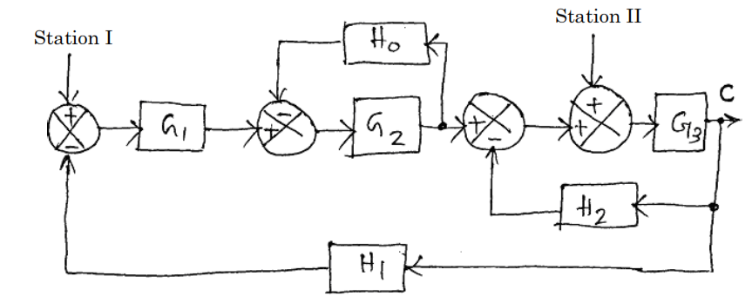
- Reduce the given block diagram and find the overall transfer function. (APR/MAY 2017) (8 MARKS) (D)
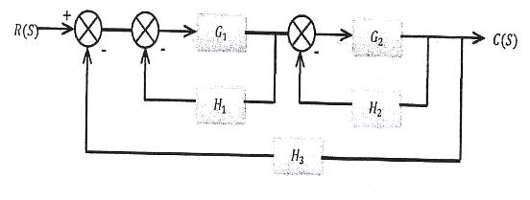
- Reduce the given block diagram and find the overall transfer function. (APR/MAY 2017) (8 MARKS)(D)
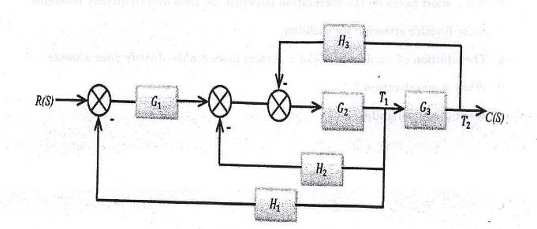
Signal Flow Graph Technique
- For the given signal flow graph find C(S)/R(S) using Mason’s Gain formula. (D) (13 Marks) (NOV/DEC 2014)
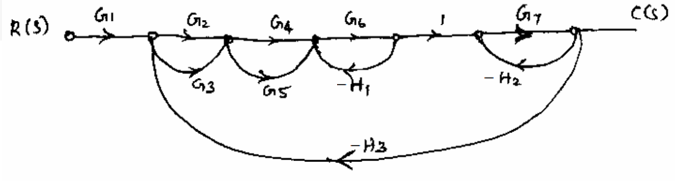
- For the given signal flow graph find C(S)/R(S) using Mason’s Gain formula. (D) (13 Marks) (NOV/DEC 2013, APR/MAY 2017)
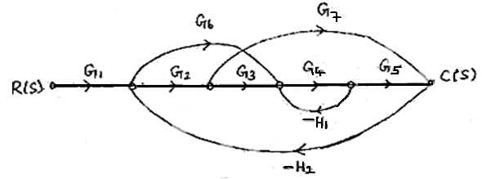
- For the given signal flow graph find C(S)/R(S) using Mason’s Gain formula. (D) (13 Marks) (NOV/DEC 2013)
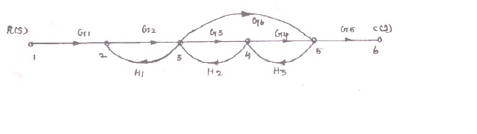
- Obtain the transfer function using Mason’s Gain Formula for the system (ID) (13 Marks) (MAY/JUNE 2013)
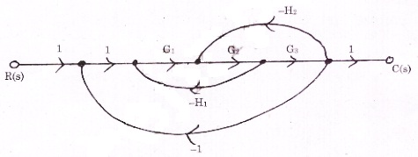
- Obtain the transfer function using Mason’s Gain Formula for the system (ID) (13 Marks) (APR/MAY 2017)
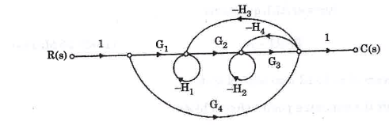
- Obtain the transfer function using Mason’s Gain Formula for the system (ID) (13 Marks) (APR/MAY 2017)
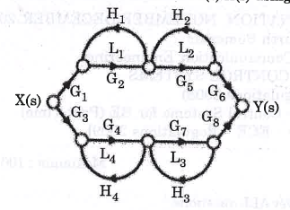
Block Diagram Reduction to Signal Flow Graph Technique
- Convert the given block diagram to signal flow graph and find the transfer function using mason’s gain formula and verify with block diagram approach. (D) (13 Marks) (MAY/JUNE 2016)
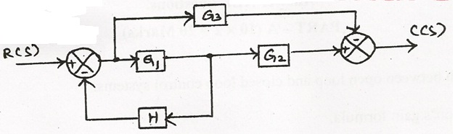
- Convert the given block diagram to signal flow graph and find the transfer function using mason’s gain formula and verify with block diagram approach. (D) (13 Marks) (MAY/JUNE 2016)
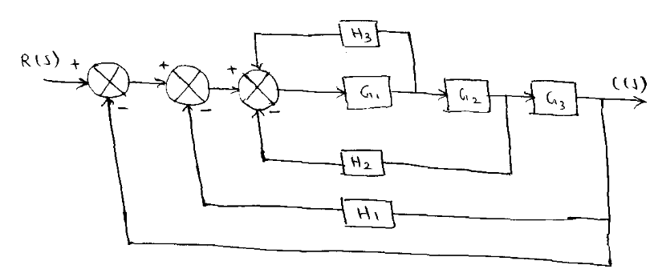
Servomotor
- Describe the features and characteristics of an armature controlled d.c. servomotor. (ID) (13 Marks) (MAY 2007, 2009)
- Explain the working of d.c. servomotors. (D) (13 Marks) (DEC 2014)
- Derive the transfer function of d.c. servomotor under field controlled. (D) ( Marks) (MAY 2005)
- Derive the transfer function of an armature controlled d.c. motor. (D) (8 Marks) (MAY 2009, DEC 2015)
- Explain the working of a.c. servomotors. (D) (8 Marks) (DEC 2014)
- Explain the principle of working of synchronous with relevant sketches. How are synchros useful in control system engineering? (ID) (13 Marks)
UNIT II
TIME RESPONSE ANALYSIS
PART - A
- Specify the time domain Specification? (ID) (NOV/DEC 2016, MAY/JUNE 2016)
- What is meant by steady state error? (D) (NOV/DEC 2016, NOV/DEC 2015)
- List the Standard test signal used in time domain analysis. (D) (MAY/JUNE 2016, MAY/JUNE 2014, NOV/DEC 2015)
- State the effect of PI Compensation in system performance. (ID) (MAY/JUNE 2016)
- How do you find the type of the system? (D) (MAY/JUNE 2015)
- Find the unit impulse response of the system H(s) = 5s/(s+2) with zero initial conditions. (ID) (MAY/JUNE 2015)
- For the system described by $\frac{C(S)}{R(S)}=\frac{16}{S^{2}+8S+16};$find the nature of the time response? (ID) (NOV/DEC 2015)
- Why is the derivative control not used in control system? (D) (NOV/DEC 2015)
- Give the relation between static and dynamic error coefficents. (ID) (NOV/DEC 2016)
- What is type and order of the system? (D) (NOV/DEC 2014, MAY/JUNE 2015)
- What are the advantages of generalized error series? (D) (NOV/DEC 2014)
- Give the transfer function of the PID Controller. (D) (NOV/DEC 2013)
- State the effect of PD Compensation in system performance. (ID) (MAY/JUNE 2014)
- What do you mean by peak over shoot? (ID) (NOV/DEC 2010)
- Define settling time. (D) (MAY/JUNE 2010)
- Differentiate between steady state and transient response of the system? (ID) (MAY/JUNE 2010)
- What is the effect of system performance when a proportional controller is introduced in a system? (ID) (MAY/JUNE 2015)
- What is type and order of the given system$G\left(S\right)= \frac{K}{S(ST+1)}$? (ID) (NOV/DEC 2014)
- Define Rise time. (D)
- Define peak time. (D)
- What is time response? (D)
- What is transient response? (D)
- Define step signal? (D)
- Define ramp signal? (D)
- Define parabolic signal? (D)
- What is position error coefficient? (ID)
- For what purpose standard test signals are used? (ID)
- What is called PI controller? (D)
- What is called I and P controller? (D)
- What is steady state response? (D)
PART – B
[First Half]
TIME RESPONSE ANALYSIS
- Define and Derive the time domain specifications of a second order system subjected to a step input (D) (13 Marks) (NOV/DEC 2016, MAY/JUNE 2016, NOV/DEC 2011, NOV/DEC 2015)
- Derive the expression for unit step response for the second order
  - Underdamped, and
  - Undamped systems. (D) (13 Marks) (NOV/DEC 2015, NOV/DEC 2014, NOV/DEC 2013)
- Derive the time response of a first order system for unit step input (D) (MAY/JUNE 2016) (8 Marks)
- The unity feedback control system is characteristic by an open loop transfer function $G\left(S\right)= \frac{K}{S(S+10)}$. Determine the gain K, so that the system will have damping ratio of 0.5 for this value of K. Determine the peak overshoot and peak time for a unit step input. (D) (MAY/JUNE 2016, MAY/JUNE 2015, MAY/JUNE 2014, NOV/DEC 2014) (13 Marks)
- The overall transfer function of a control system is given by $\frac{C(S)}{R(S)}=\frac{16}{S^{2}+1.6S+16}.$ It is desired that the damping ratio be 0.8. Determine the derivative rate feedback constant K₁ and compare rise time, peak time, maximum overshoot and steady state error for unit ramp input function without and with derivative feedback control. (ID) (13 Marks) (NOV/DEC 2016)
[Second Half]
STATIC AND DYNAMIC ERROR
- For a unity feedback control system the open loop transfer function is given by
$G\left(s\right)= \frac{10(S+2)}{S^{2}(S+1)}$, find
  - The position, velocity, acceleration error constants
  - The steady state error when R(s) = $\frac{3}{S}-\frac{2}{S^{2}}+\frac{1}{{3S}^{3}}$(D) (NOV/DEC 2016, MAY/JUNE 2016) (13 Marks)
- The open loop transfer function of a unity feedback control system is given by$G\left(S\right)= \frac{K}{S(S+1)}$. The input of the system is described by r(t)=4+6t. Find the generalized error coefficients and steady state error. (ID) (NOV/DEC 2015) (8 Marks)
- The unity feedback control system has the forward transfer function $G\left(S\right)= \frac{KS}{{(S+1)}^{2}}$. For the input r(t)=1+5t. Find the Minimum value of K so that the steady state error is less than 0.1. (ID) (8 Marks) (MAY/JUNE 2015)
- The open loop transfer function of a servo system with unity feedback is $G\left(S\right)= \frac{10}{S(0.1S+1)}$. Evaluate the static error constants (Kp, Kv, Ka) for the system. Obtain the steaty stae error of the system when subjected to an input given by the polynomial $r\left(t\right)=a_{0}+a_{1}t+\frac{a_{2}}{2}t^{2}$ (D) (13 Marks) (MAY/JUNE 2015, MAY/JUNE 2014, NOV/DEC 2010)
- For the open loop system with $G\left(S\right)= \frac{1}{(S+1)}$ and $H\left(S\right)= 5$, Calculate the generalized error coefficients and error series (D) (NOV/DEC 2013) (8 Marks)
CONTROLLERS
- Write short notes on : i) PD controller ii) PI controller. (D) (13 Marks) (DEC 2014, 2016, MAY 2008)
- Discuss the effect on the performance of a second order control system of the proportional derivative control. (ID) (13 Marks) (MAY 2009, 2012)
- Explain about the following controllers. I) P controller ii) PI controller iii) PID controller (D) (13 Marks) (DEC 2009, 2015, 2017, MAY 2016)
- With the help of diagrams and equations, explain the following controllers : i) proportional ii) Integral iii) Derivative (ID) (13 Marks) (DEC 2012)

UNIT III
FREQUENCY RESPONSE AND SYSTEM ANALYSIS
PART - A
- What is bode plot? (D) (APR/MAY 2016)
- Define gain margin and phase margin. (D) (NOV/DEC 2011, APR/MAY 2010, NOV/DEC 2014, APR/MAY 2015)
- Define Resonant Peak and Resonant Frequency. (D) (MAY/JUNE 2014, NOV/DEC 2014)
- Mention any four frequency response specifications. (D) (NOV/DEC 2010)
- What are m & n circles? (ID) (NOV/DEC 2011, MAY/JUNE 2014)
- Define Corner Frequency. (D) (NOV/DEC 2012)
- What is Nichol’s chart? (D) (NOV/DEC 2012)
- What is Gain and Phase Crossover Frequency? (D) (NOV/DEC 2013)
- List the advantages of Nichol’s chart? (D) (NOV/DEC 2010).
- What are the Frequency Domain Specifications. (D) (NOV/DEC 2016).
- Define –Resonant Peak (D)
- What is bandwidth? (D)
- Define Cut-off rate? (D)
- What are the main advantages of Bode plot? (D)
- Define Phase cross over? (D)
- Define Gain cross over? (D)
- What is a polar plot? (D)
- What are compensators? (D)
- What are the two types of compensation techniques write short notes on them? (D)
- Define Lead compensator. (D)
- What is a lag compensator? (D)
- What is a lag lead compensator? (D)
- What is the need for compensator? (D) (NOV/DEC 2011, MAY/JUNE 2014, MAY/JUNE 2015, NOV/DEC 2014, NOV/DEC 2010)
- Sketch the electrical circuit of a Lag, Lead, lag-lead compensator. (ID) (NOV/DEC 2011, NOV/DEC 2010)
- Write the transfer function and pole zero plot of lag, lead and lag-lead compensator. (D) (MAY/JUNE 2014, NOV/DEC 2010)
- What is the relation between$φ_{m} and α$? (ID) (APR/ MAY 2010)
- What type of compensator suitable for high frequency noisy environment? (ID) (APR/ MAY 2010)
- What is desired performance criteria specified in compensator design? (ID)
- How the closed loop frequency response is determined from the open loop frequency response. (ID)
- What are the two situations in which compensation is required? (ID)

PART B
[First Half]
BODE PLOT
- Plot the Bode diagram for the following transfer function and obtain the gain and phase cross over frequencies. (D) (13 Marks) (APR/MAY 2011, NOV/DEC 2014)
$$G\left(S\right)= \frac{10}{S \left(1+0.4S\right)\left(1+0.1S\right)}$$
- Sketch the Bode plot and hence find Gain cross over frequency, Phase cross over frequency, Gain margin and Phase margin. (D) (13 Marks) (NOV/DEC 2011, APR/MAY 2010, APR/MAY 2013, NOV/DEC 2014, APR/MAY 2015)
$$G\left(S\right)= \frac{0.75\left(1+0.2S\right)}{ S \left(1+0.5S\right)\left(1+0.1S\right)}$$
- Sketch the Bode plot and hence find Gain cross over frequency, Phase cross over frequency, Gain margin and Phase margin. (D) (13 Marks) (NOV/DEC 2013, NOV/DEC 2016)
$$G\left(S\right)= \frac{10(S+3) }{ S(S+2) (S^{2} +4S+100) }$$
- Plot the Bode diagram for the following transfer function and obtain the gain and phase cross over frequencies (D) (13 Marks)
$$G\left(S\right)= \frac{KS^{2}}{\left(1+0.2S\right)\left(1+0.02S\right)}$$
Determine the value of K for a gain cross over frequency of 20 rad/sec.
- Sketch the Bode plot and hence find Gain cross over frequency, Phase cross over frequency, Gain margin and Phase margin. (D) (13 Marks) (NOV/DEC 2010, APR/MAY 2015)
$$G\left(S\right)= \frac{10(1+0.1S) }{S (1+0.01S) (1+S). }$$
POLAR PLOT
- The open loop transfer function of a unity feedback system is
$$G\left(S\right)= \frac{1}{S \left(1+S\right)\left(1+2S\right)}$$
Sketch the Polar plot and determine the Gain margin and Phase margin. (D) (13 Marks) (NOV/DEC 2010, NOV/DEC 2014)
- Sketch the polar plot for the following transfer function and find Gain cross over frequency, Phase cross over frequency, Gain margin and Phase margin. (D) (13 Marks) (APR/MAY 2010, NOV/DEC 2016)
$$G\left(S\right)= \frac{10(S+2) (S+4) }{S (S^{2}+3S+10) }$$
- Sketch the polar plot for the following transfer function .and find Gain cross over frequency, Phase cross over frequency, Gain margin and Phase margin. (D) (13 Marks) (APR/MAY 2015)
$$G\left(S\right)= \frac{400}{S (S+2) (S+10)}$$

[Second Half]
NICHOL’S PLOT
- A unity feedback system has open loop transfer function

$G\left(S\right)= \frac{20}{S \left(S+2\right)\left(S+5\right)}$.
Using Nichol’s chart. Determine the closed loop frequency response and estimate all the frequency domain specifications. (D) (13 Marks) (NOV/DEC 2013, APR/MAY 2014)
- Draw the Nichol’s plot for the system whose open loop transfer function is G(S) H(S) =K / S (S+2) (S+10). Determine the range of K for which closed loop system is stable. (D) (13 Marks)
- Construct Nichol’s plot for a feedback control system whose open loop transfer function is given by G(S) H(S) =5/ S(1+S).Comment on the stability of open loop and closed loop transfer function. (D) (13 Marks)
- Sketch the Nichol’s plot for a system with the open loop transfer function G(S) H(S) =K (1+0.5S) (0.01+S) / (1+10S) (S+1). Determine the range of values of K for which the system is stable. (D) (13 Marks)
LEAD COMPENSATOR
- Explain the design procedure of a lead compensator with suitable example. (D) (13 Marks) (NOV/DEC 2011)
- The open loop transfer function of the uncompensated system is $G\left(s\right)= \frac{5}{S(S+2)}.$Design a suitable compensator for the system so that the static velocity error constant $K_{V}=20\sec^{-1}$, the phase margin is atleast 55° and the gain margin is atleast 12dB(ID) (13 Marks) (NOV/DEC 2013, APR/MAY 2010, MAY/JUNE 2016)
- Consider the unity Feedback system has an open loop transfer function is
$$G\left(s\right)= \frac{K}{S(0.1S+1)(0.2S+1)}.$$
The system is compensated using a suitable lead compensator to meet the following specifications:
- Phase Margin of atleast 50°;
- Bandwidth = 12 rad/sec;
- Velocity error constant $K_{V}≥30\sec^{-1}$(MAY/JUNE 2016) (D) (13 Marks)
LAG COMPENSATOR
- Explain the design procedure of a lag compensator with suitable example. (D) (13 Marks) (MAY/JUNE 2014, MAY/JUNE 2015)
- To open transfer function of a system is given below $G\left(s\right)= \frac{K}{S(S+1)(S+4)}.$
Design a suitable lag compensator to meet the following specifications. Phase Margin = 43°; Bandwidth = 1.2 rad/sec; Velocity error constant $K_{V}≥5\sec^{-1}$(NOV/DEC 2011) (D) (13 Marks)
- A Unity Feedback system has an open loop transfer function $G\left(s\right)= \frac{K}{S(S+1)(0.5S+1)}.$
Design a suitable lag compensator to maintain the Phase Margin of atleast 40°; Bandwidth = 1.2 rad/sec; Velocity error constant $K_{V}≥5\sec^{-1}$(MAY/JUNE 2016) (D) (13 Marks)
LAG - LEAD COMPENSATOR (13 MARKS)
- Explain the design procedure of a Lag- Lead compensator with suitable example. (D) (13 Marks) (MAY/JUNE 2010, MAY/JUNE 2015)
- The open loop transfer function of the uncompensated system is $G\left(s\right)= \frac{1}{S(S+1)(S+2)}.$Compensate the system by cascading suitable lag – lead compensator for the system so that the static velocity error constant $K_{V}=10\sec^{-1}$, the phase margin is atleast 45° and the gain margin is atleast 10dB or more. (NOV/DEC 2013) (D) (13 Marks)

UNIT IV
CONCEPTS OF STABILITY ANALYSIS
PART - A
- Define stability. (D) (MAY/JUNE 2016)
- What is nyquist contour (D)
- Define Relative stability. (D)
- What will be the nature of impulse response when the roots of characteristic equation are lying on imaginary axis? (ID)
- What is the relationship between Stability and coefficient of characteristic polynomial? (ID)
- What is limitedly stable system? (ID)
- In routh array what conclusion you can make when there is a row of all zeros? (ID)
- What are the two segments of Nyquist contour? (ID)
- State any two limitations of routh stability criterion. (D) (NOV/DEC 2012)
- State the advantages of nyquist stability criterion over routh criterion. (D) ( NOV/DEC 2012)
- What is BIBO stability criterion? (D) (NOV/DEC 2011)
- State Nyquist Stability Criterion. (D) (APR/ MAY 2010, NOV/DEC 2013, MAY/JUNE 2014, NOV/DEC 2010)
- How are the location of roots of the characteristic equation related to stability? (D) (MAY/JUNE 2014, MAY/JUNE 2015, NOV/DEC 2014)
- Define Routh Stability Criterion? (D) (MAY/JUNE 2014, MAY/JUNE 2015, NOV/DEC 2014)
- What is dominant pole? (D) (NOV/DEC 2016, NOV/DEC 2015, MAY/JUNE 2015)
- How will you find the root locus on real axis? (ID) (MAY/JUNE 2016)
- State the basic properties of root locus. (D) (NOV/DEC 2016)
- What is the condition for the system $G\left(s\right)= \frac{K(s+a)}{s(s+b)}$ to have a circle in root locus? (D) (NOV/DEC 2013)
- What is the value of K at any given point in root locus? (D) (MAY/JUNE 2015, NOV/DEC 2010)
- What will be the nature of Step response when the roots of characteristic equation are lying on imaginary axis? (D)
- What are the conditions for a linear time invariant system to be stable? (ID)
- What do you mean by asymptotic stability? (ID)
- How the system is classified based on stability? (D)
- What does the positive of the coefficients of characteristic equation indicate? (ID)
- State the conditions under which the coefficients can be zero or negative. (D)
- How the roots of characteristic equation are related to stability? (ID)
- What will be the nature of ramp response when the roots of characteristic equation are lying on imaginary axis? (D)
- What will be the nature of impulse response when the roots of characteristic equation are lying on right half of the S-plane? (D)
- How will you find the gain K at a point on the root locus? (D)
- Give the effect of addition of poles on the root locus. (ID)

PART – B
[First Half]
ROUTH HURWITZ CRITERION
- Determine the range of K for stability of unity feedback system whose open loop transfer function in $G\left(s\right)= \frac{K}{s(s+1)(s+2)}$ using Routh Stability Criterion. (D) (13 Marks) (NOV/DEC 2012)
- Construct Routh Array and determine the stability of the system whose characteristic equation is $S^{6}{+2S}^{5}{+8S}^{4}{+12S}^{3}{+20S}^{2}+16S+16=0.$Also determine the number of roots lying on right half of s – plane, left half of s-plane and on imaginary axis. (ID) (13 Marks) (NOV/DEC 2011)
- Determine the stability of the given system of the given characteristic equation using Routh-Hurwitz Criterion
    - $S^{5}{+4S}^{4}{+8S}^{3}{+8S}^{2}+7S+4=0$
    - ${S^{6}+S}^{5}{+3S}^{4}{+3S}^{3}{+3S}^{2}+2S+1=0$(D) (13 Marks) (MAY/JUNE 2015)
- The open loop transfer function of a unity feedback control system is given by $G\left(s\right)= \frac{K}{(s+2)(S+4)(S^{2}+6S+25)}$. By applying Routh criterion, dicuss the stability of the closed loop system as a function of K. Determine the values of K which will cause sustained oscillations in the closed loop system. What are the corresponding oscillation frequencies? (D) (13 Marks) (MAY/JUNE 2014)
- Consider the closed – loop system shown in the figure, determine the range of K for which the stable. (ID) (13 Marks) (MAY/JUNE 2016)
+
-
$$\frac{K}{{(S}^{2}+S+1)(S^{2}+4S)}$$

NYQUIST STABILITY CRITERION (13 MARKS)
- The open loop transfer function of a unity feedback system is given by
$G\left(s\right)H\left(s\right)= \frac{5}{S(S+1)(S+2)}$. Draw the nyquist plot and hence find out whether the system is stable or not. (D) (13 Marks) (NOV/DEC 2013)
[Second Half]
ROOT LOCUS (13 MARKS)
- With neat steps write down the procedure for construction of root locus. Each rule gives an example. (D) (13 Marks) (NOV/DEC 2016, NOV/DEC 2015)
- A unity Feedback Control system has an open loop transfer function
$$G\left(s\right)= \frac{K}{{S(S}^{2}+4S+13)}$$
Sketch the root locus. (D) (13 Marks) (MAY/JUNE 2016, NOV/DEC 2010)
- A single loop negative feedback system has a transfer function $G_{c}\left(s\right)G\left(s\right)=\frac{{K(S+6)}^{2}}{S(S^{2}+1)(S+4)}$. Skectch the root locus as a function of K. Find the range of K for which the system is stable. (D) (13 Marks) (MAY/JUNE 2015)
- Draw the root locus of the system is given by $G\left(s\right)= \frac{K(S+1)}{{S(S}^{2}+5S+20)}$. (D) (13 Marks) (NOV/DEC 2016)
- Plot the root locus for a unity feedback closed loop system whose open loop transfer function is$G\left(s\right)= \frac{K}{{S(S+4)(S}^{2}+2S+2)}$. (D) (13 Marks) (NOV/DEC 2011)
- Sketch the root locus of a unity feedback system with an open loop transfer function$G\left(s\right)= \frac{K}{S(S+2)(S+4)}$. Find the value of K so that the damping ratio of the closed loop system is 0.5. (D) (13 Marks) (MAY/JUNE 2015, MAY/JUNE 2014)
- Sketch the root locus of a unity feedback system with an open loop transfer function$G\left(s\right)= \frac{K(S+0.5)}{S^{2}\left(S+4.5\right)}$. (D) (13 Marks) (NOV/DEC 2013)
- The open loop transfer function of a unity feedback system is given by
$$G\left(s\right)= \frac{K(S+9)}{{S(S}^{2}+4S+11)}$$
Sketch the root locus. (D) (13 Marks) (NOV/DEC 2015)
- Sketch the root locus of a unity feedback system with an open loop transfer function
$G\left(s\right)= \frac{K}{S(S+1)(S+2)}$. (D) (13 Marks) (NOV/DEC 2014)

UNIT V
CONTROL SYSTEM ANALYSIS USING STATE VARIABLE METHODS
PART - A
- Define State and State Variable. (D) ( NOV/DEC 2012, NOV/DEC 2015, APR/MAY 2016)
- What is controllability? (D) (APR/MAY 2015)
- What is observability? (D) (APR/MAY 2015)
- Write the properties of state transition matrix. (D) May/June 2014
- What is modal matrix? (D)
- State the duality between controllability and observability. (ID)
- What are the methods available for the stability analysis of sampled data control system? (ID)
- What is the necessary condition to be satisfied for design using state feedback? (ID)
- What is similarity transformation? (ID)
- What is meant by diagonalization? (D)
- What is the need for controllability test? (D)
- What is the need for observability test? (D)
- What is the need for state observer? (D)
- What is the pole placement by state feedback? (ID)
- How control system design is carried in state space? (ID)
- What is state transition matrix? (D) (NOV/DEC 2016, NOV/DEC 2015)
- When do you say the system is completely controllable? (ID) (NOV/DEC 2015)
- State the limitations of state variable feedback? (D) (NOV/DEC 2016)
- Define Sampling Theorem? (D) ( NOV/DEC 2012, NOV/DEC 2015, APR/MAY 2016)
- Draw Sample and hold circuits. (D)
- Mention the need for state variables? (D) Nov/Dec2010
- Name methods of state space representation for phase variables. (D) May 2011
- What is meant by quantization? (D) May 2011&May/June 2012
- How the model matrix is determined? (D) May/June 2012
- What is meant by sampled data controlled system? (D) Nov/Dec 2012
- What are the advantages of state space representation? (D) May/June 2013
- Define state equation? (D) Nov/Dec 2013
- Give the concept of controllability. (D) Nov/Dec 2013
- Draw the circuit diagram of sample and hold circuit. (D) May/June 2014
- Define state model of nth order system? (D) Nov/Dec 2014
- What are sampler and hold circuits? (D) Nov/Dec 2014
PART – B
[First Half]
State Model Transformation
- Consider the following system with differential equation given by
$$\overset{⃛}{y}+6\ddot{y}+11\dot{y}+6y=6u$$
Obtain the state model in diagonal canonical form. (D) (13 Marks) (NOV/DEC 2015)
- Construct the state model for the system characterized by the differential equation $\frac{d^{3}x}{{dt}^{3}}+6\frac{d^{2}x}{{dt}^{2}}+11\frac{dx}{dt}+6x+u=0$ (APR/MAY 2016) (D) (13 Marks)
- Consider the system is defined by X = Ax+Bu and Y = Cx, Where
$$A=\left[\begin{matrix}0 & 1 & 0 \\ 0 & 0 & 1 \\ -6 & -11 & -6\end{matrix}\right];B=\left[\begin{matrix}1 \\ 0 \\ 1\end{matrix}\right] ;C= \left[\begin{matrix}10 & 5 & 1\end{matrix}\right]$$
Obtain the diagonal canonical form of the state model by a suitable transformation matrix. (D) (13 Marks) (APR/MAY 2016)
- Obtain the state model of the mechanical translational system in which f(t) is input and x2(t) is output. (ID) (13 Marks) (NOV/DEC 2015)

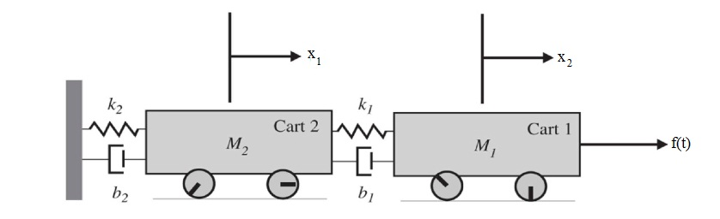
State Model to Transfer Function
- Convert the given state model to transfer function. (D) (13 Marks)
$$\left[\dot{x}\right]=\left[\begin{matrix}0 & 1 & 0 \\ 0 & 0 & 1 \\ -8 & -14 & -7\end{matrix}\right]\left[\begin{matrix}x_{1} \\ x_{2} \\ x_{3}\end{matrix}\right]+\left[\begin{matrix}0 \\ 0 \\ 1\end{matrix}\right]u$$
$$y\left(t\right)= \left[\begin{matrix}15 & 5 & 0\end{matrix}\right]\left[\begin{matrix}x_{1} \\ x_{2} \\ x_{3}\end{matrix}\right]$$
- Consider the system is defined by X = Ax+Bu and Y = Cx, Where
$$A=\left[\begin{matrix}-7 & 1 & 0 \\ -14 & 0 & 1 \\ -8 & 0 & 0\end{matrix}\right];B=\left[\begin{matrix}20 \\ 125 \\ 185\end{matrix}\right] ;C= \left[\begin{matrix}1 & 0 & 0\end{matrix}\right]$$
Obtain the transfer function of the state model. (D) (13 Marks)
- Convert the given state model to transfer function (D) (13 Marks)
$$\left[\begin{matrix}{\dot{x}}_{1} \\ {\dot{x}}_{2} \\ {\dot{x}}_{3}\end{matrix}\right]=\left[\begin{matrix}3 & 1 & 0 \\ 0 & 3 & 1 \\ 0 & 0 & 3\end{matrix}\right]\left[\begin{matrix}x_{1} \\ x_{2} \\ x_{3}\end{matrix}\right]+\left[\begin{matrix}0 \\ 0 \\ 1\end{matrix}\right]u$$
$$y\left(t\right)= \left[\begin{matrix}2 & 0 & 0\end{matrix}\right]\left[\begin{matrix}x_{1} \\ x_{2} \\ x_{3}\end{matrix}\right]$$
[Second Half]
Controllability and Observability
- Determine whether the system described by the following state model is completely controllable and observable (D) (13 Marks) (NOV/DEC 2016, APR/MAY 2016)
$$\left[\dot{x}(t)\right]=\left[\begin{matrix}0 & 0 & 1 \\ -2 & -3 & 0 \\ 0 & 2 & -3\end{matrix}\right]\left[\begin{matrix}x_{1}(t) \\ x_{2}(t) \\ x_{3}(t)\end{matrix}\right]+\left[\begin{matrix}0 \\ 2 \\ 0\end{matrix}\right]u(t)$$
$$y\left(t\right)= \left[\begin{matrix}1 & 0 & 0\end{matrix}\right]\left[\begin{matrix}x_{1}(t) \\ x_{2}(t) \\ x_{3}(t)\end{matrix}\right]$$
- Determine whether the system described by the following state model is completely controllable and observable (D) (13 Marks) (APR/MAY 2015)
$$\left[\dot{x}\right]=\left[\begin{matrix}0 & 1 & 0 \\ 0 & 0 & 1 \\ -1 & -5 & -1\end{matrix}\right]\left[\begin{matrix}x_{1} \\ x_{2} \\ x_{3}\end{matrix}\right]+\left[\begin{matrix}0 \\ 5 \\ -24\end{matrix}\right]u$$
$$y\left(t\right)= \left[\begin{matrix}1 & 0 & 0\end{matrix}\right]\left[\begin{matrix}x_{1} \\ x_{2} \\ x_{3}\end{matrix}\right]$$
- Consider the system is defined by X = Ax+Bu and Y = Cx, Where
$$A=\left[\begin{matrix}0 & 1 & 0 \\ 0 & 0 & 1 \\ -6 & -11 & -6\end{matrix}\right];B=\left[\begin{matrix}1 \\ 0 \\ 1\end{matrix}\right] ;C= \left[\begin{matrix}10 & 5 & 1\end{matrix}\right]$$
Check the controllability and observability of the system. (D) (13 Marks) (NOV/DEC 2015, APR/MAY 2016)
Digital Control System
- State the advantages of digital control systems. (D) (6 Marks) ( MAY 2016, DEC 2017)
- Draw and explain the block diagram of sampled data system and digital data system. (D) (8 Marks) (MAY 2015, DEC 2017)
- Write detailed notes on Sampler and hold circuits. (D) (8 Marks) (MAY 2016)
- Explain the function modules of closed loop sampled data system and compare its performance with open loop sampled data system. (D) (13 Marks) (MAY 2015)

